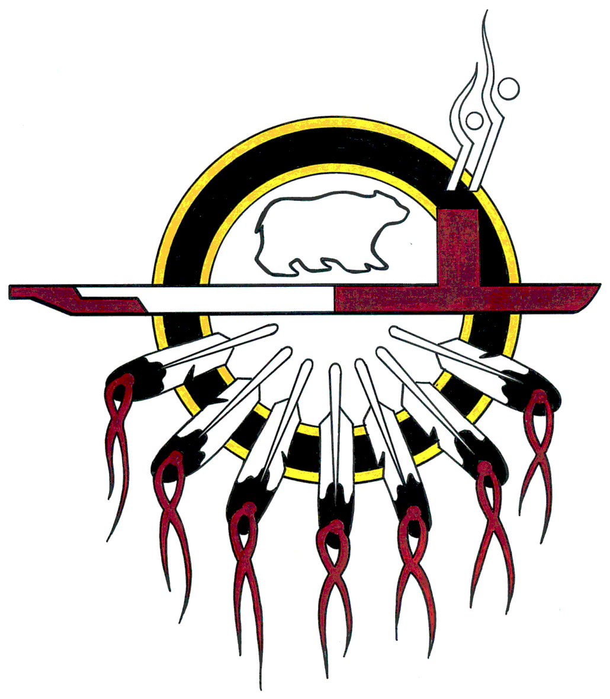

‘Mobile Healing’
Information Sheet

Anishnawbe Health Toronto’s ‘Mobile Healing’ RV will bring COVID-19 testing capability to the Indigenous homeless living rough on the streets of Toronto.

Previous pandemics such as SARS and H1N1 proved to be especially traumatic, distressful, and overwhelming to the health and well- being of Indigenous people. Death, too often was the outcome. Health risk factors and their high prevalence among Indigenous people include diabetes, respiratory illnesses such as pneumonia and others present as vulnerabilities to infectious viruses like COVID-19.
Indigenous people make-up 1 to 2 per cent of Toronto’s population and is disproportionately represented at 16 per cent of the homeless population, a high of 38 per cent sleep outdoors.*

The ‘MOBILE HEALING’ RV in addition to COVID-19 testing will also provide:

- Primary health care
- Wound care
- Rapid access to housing and supports
- Mental health + Addiction supports/referral
- Emergency supplies i.e. water

Staffing for the ‘MOBILE HEALING’ RV will include a Nurse Practitioner, Mental Health & Addictions Counsellor and Housing Worker. Starting June 1, service will operate Monday through Friday, 9:30 AM to 5:00 PM. For additional information please contact: Jane Harrison, Coordinator ‘Mobile Healing’ at 416 920-2605 (269) or 416 305-3192. Jharrison@aht.ca

*Street Needs Assessment, 2018, City of Toronto

